To: Vinny Saccenti

Re: Securing the Secret Recipe

From: Team3

Hello Mr. Vinny Saccenti, we have cracked the hash and discovered it was an MD5 hash that translated into **‘password1’**. We have looked at password policies and have more deeply researched active directory, 2FA, SQL, and pwquality. We decided to use pwquality on our Ubuntu machines and set the minimum password length to 16. Below the showing hash decryption and the command line when adding the password policy.

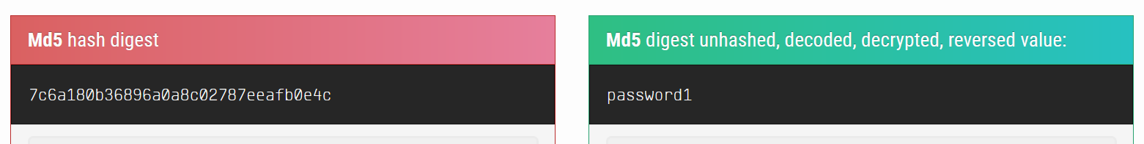



Best,

Team3